**Lab: DOM Manipulations**

Problems for in-class lab for the "[Free JS for Front-End Course @ SoftUni](https://softuni.bg/trainings/2946/js-for-front-end-march-2020)". Submit your solutions in the SoftUni judge system at <https://judge.softuni.bg/Contests/Practice/Index/2238#0>

1. **Delete from Table**

Write a program that **takes** an **email** from an **input field** and **deletes** the matching row from a table. If no entry is found, an **error** should be displayed in a **<div>** with ID "**results**". The error should be "**Not found**." Submit **only** the **deleteByEmail()** function in judge.

**Examples**

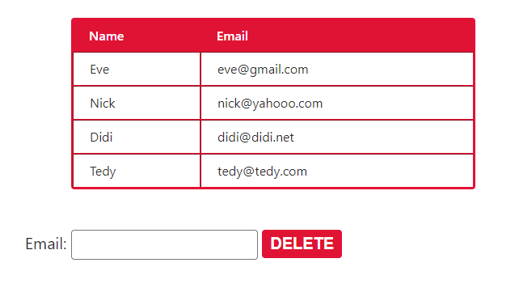

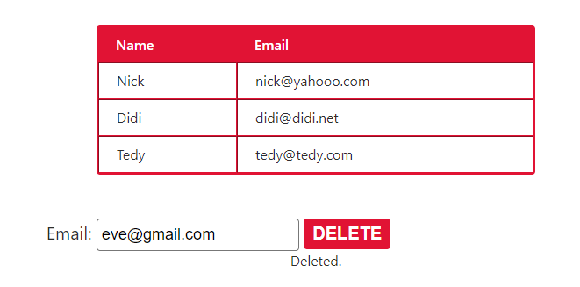

1. **Stopwatch**

Write a **timer** that counts **minutes** and **seconds**. The user should be able to control it with **buttons**. Clicking **[Start]** **starts** the **counter.** Clicking **[Stop]** **resets** the timer back to **zero**. Only **one** of the buttons should be **enabled** at a time (you cannot stop the timer, if it is not running).

Submit only the **stopwatch()** function in judge.

**Examples**

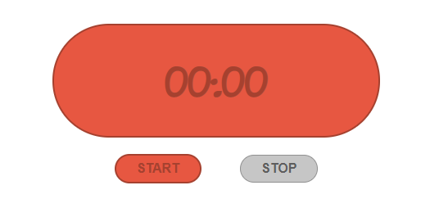

## Notification

Write a JS function that receives a string **message** and **displays** it inside a div with id "**notification**" for 2 seconds. The div starts **hidden** and when the function is called, **reveal** it. After 2 seconds, **hide** the div. In the example document, a notification is shown when you click the button.

### Example

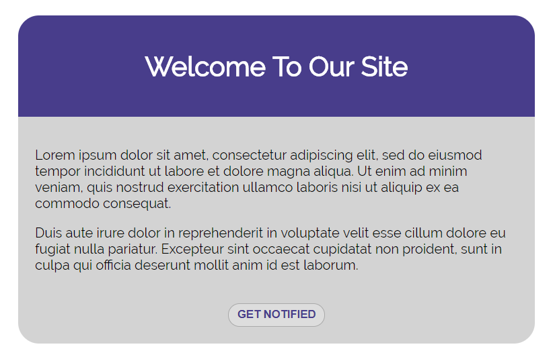

When we click the **[Get notified]** **button** a div appears in our upper-right corner. It should **disappear** in 2 seconds.

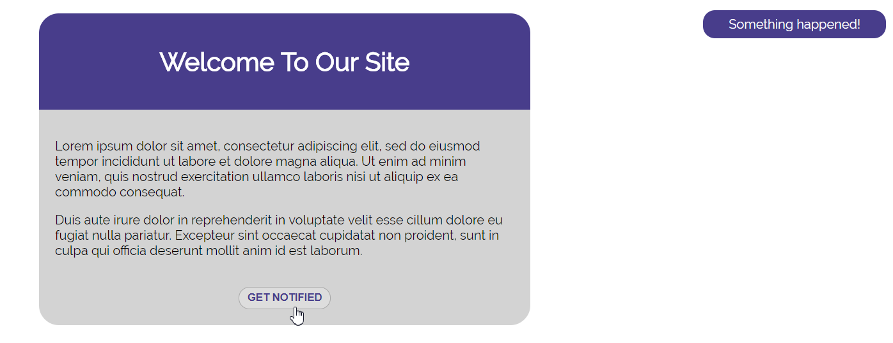

1. **Mouse Gradient**

Write a program that **detects** and **displays** how far along a gradient the user has **moved** their **mouse**. The result should be **rounded down** and displayed as a **percentage** inside the **<div>** with ID "**result**".

Submit **only** the **attachGradientEvents()** function in judge.

**Examples**

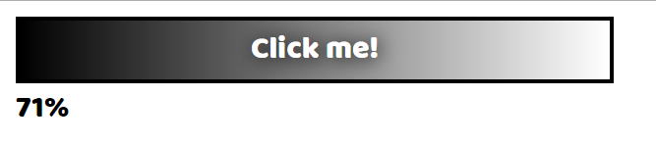

1. **Highlight Active**

Write a function that **highlights** the **currently active** section of a document. There will be **multiple** divs with **input fields** inside them. Set the **class** of the **div** that contains the **currently focused** input field to "**focused**". When focus is lost (**blurred**), **remove the class** from the element.

Submit only the **focus()** function in judge.

**Example**

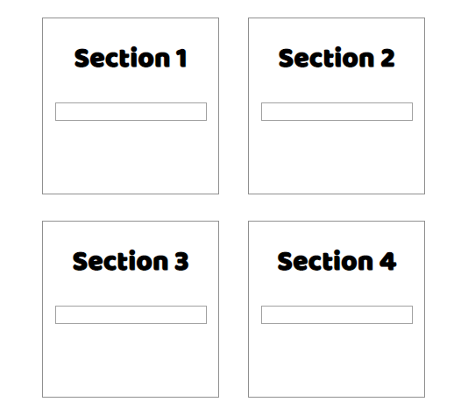 🡪 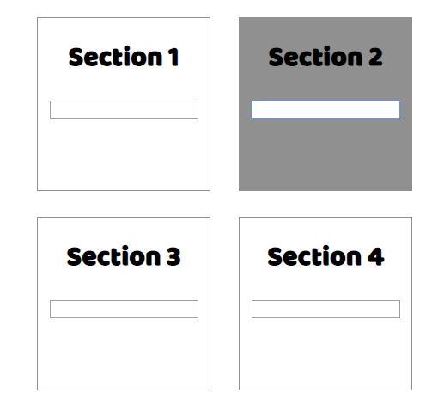

1. **Dynamic Validation**

Write a function that **dynamically validates** an **email** input field when it is **changed**. If the input is **invalid**, apply the style "**error**". Do **not** validate on every keystroke, as it is annoying for the user, consider only **change** events.

A valid email is considered to be in the format: **<name>@<domain>.<extension>**

Only **lowercase Latin characters** are allowed for any of the parts of the email. If the input is valid, **clear** the style. Submit **only** the **validate()** function in judge.

**Example**

 